We can achieve this using named vectors for the choices argument, in the format of "Human readable label" = "variable_name".

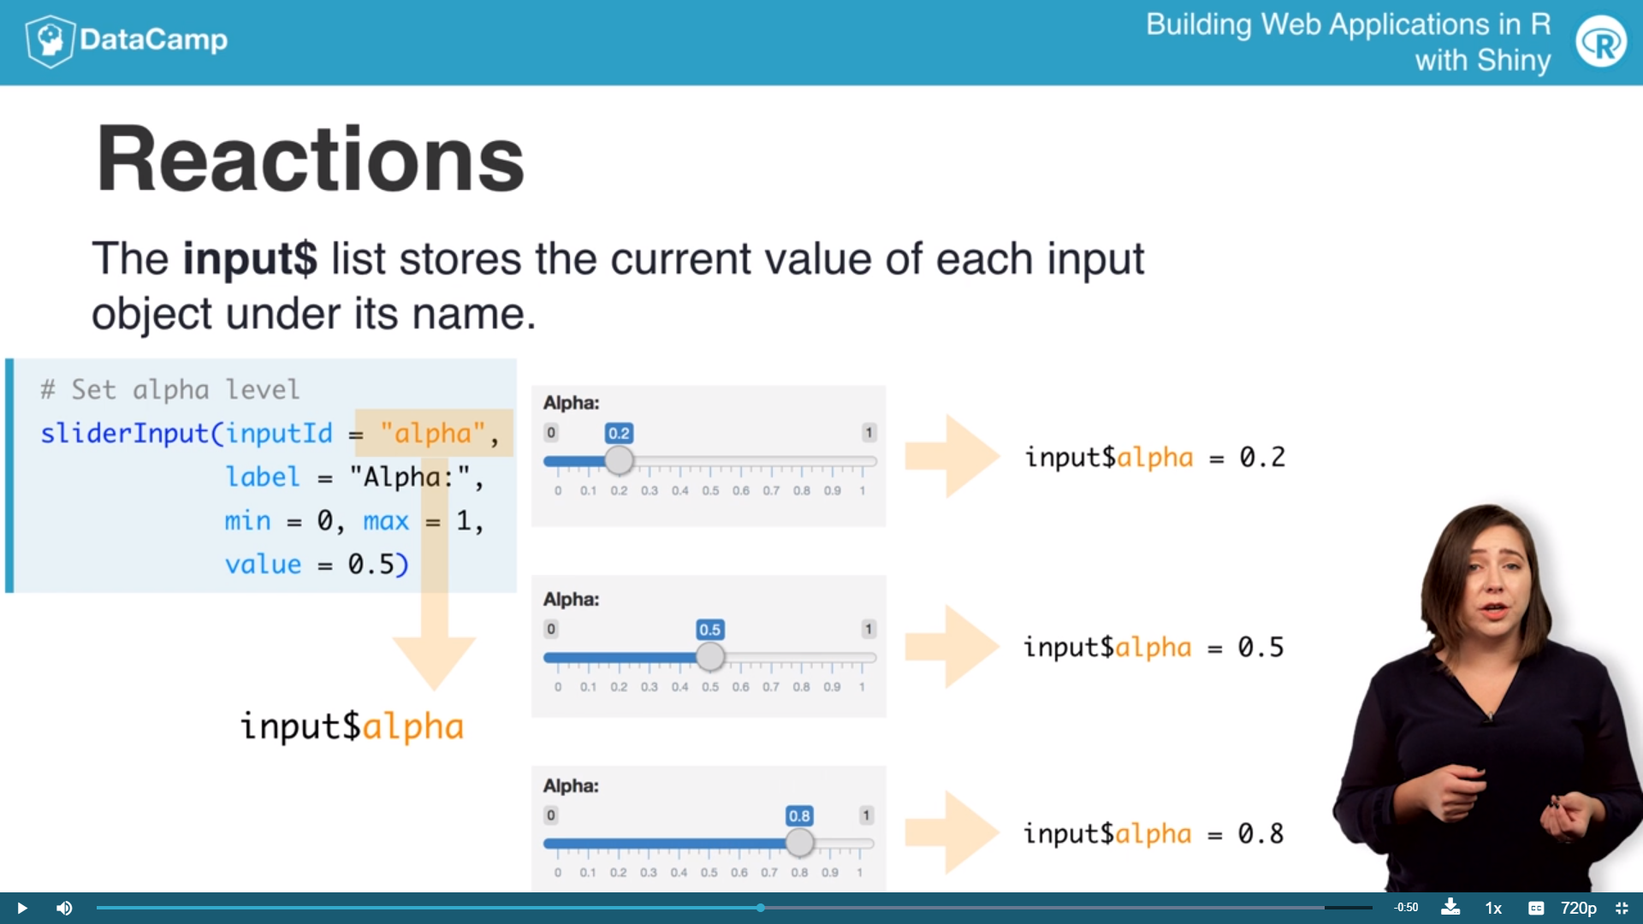

Vale=預設拉霸數值位置

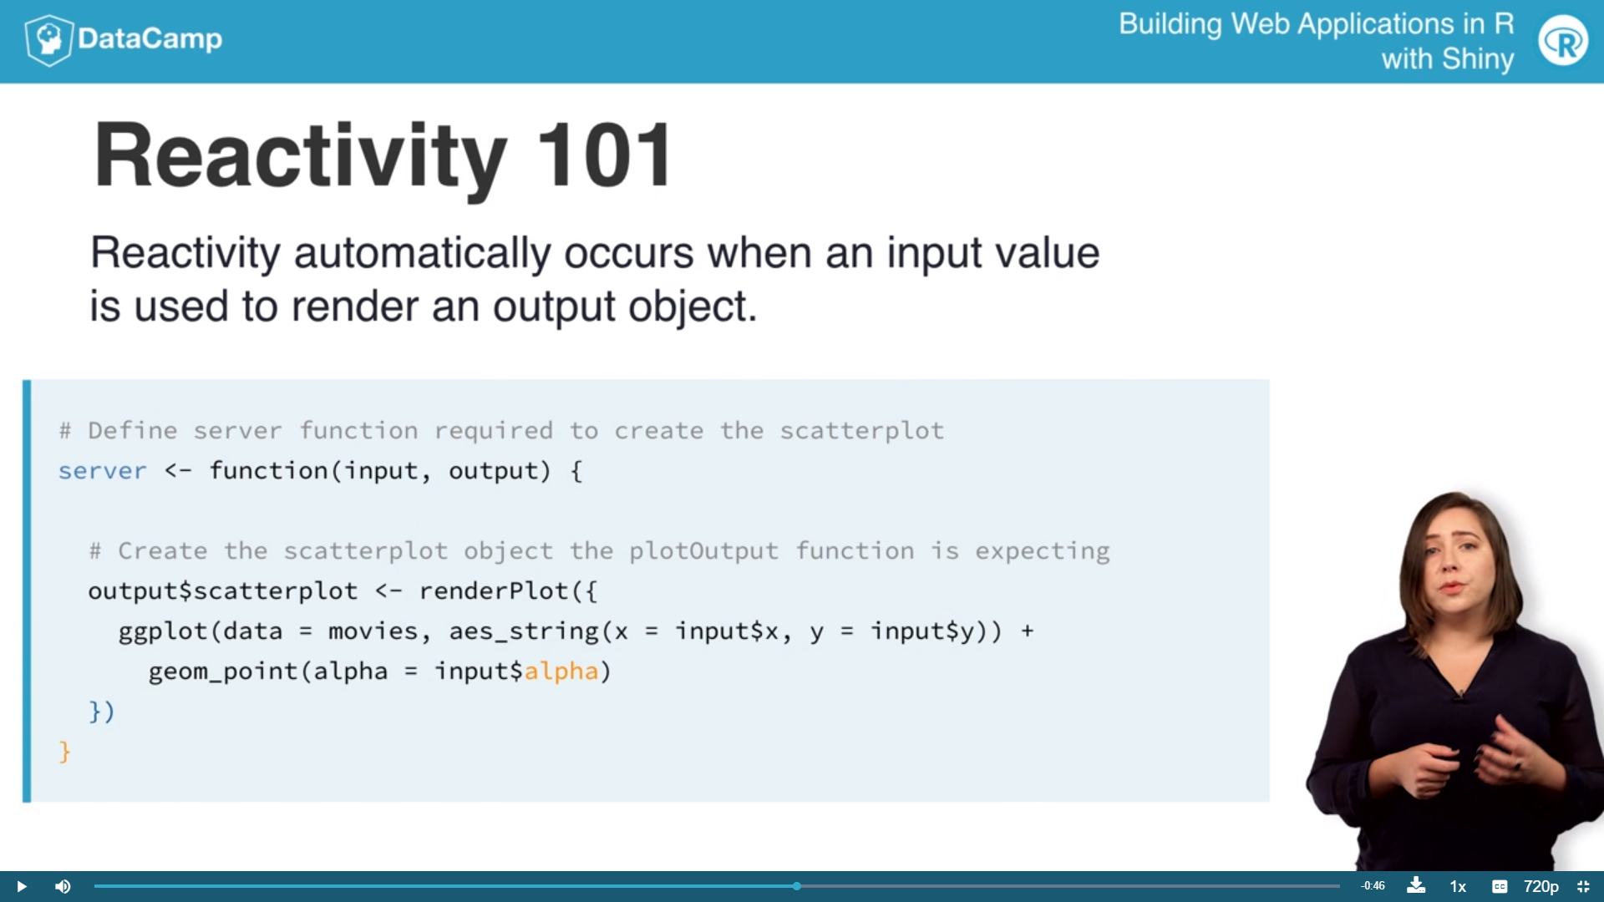

* Reduce the height of the new plot using the height argument in the plotOutput function to height = 200.
* mainPanel(

plotOutput(outputId = "scatterplot",height=200),

plotOutput(outputId = "densityplot",height=200)同時顯示兩張圖

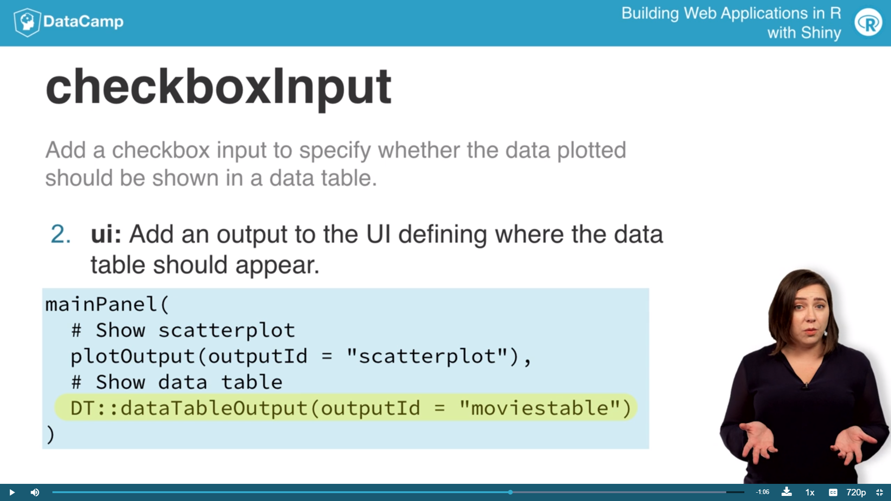

上圖需要library(DT)

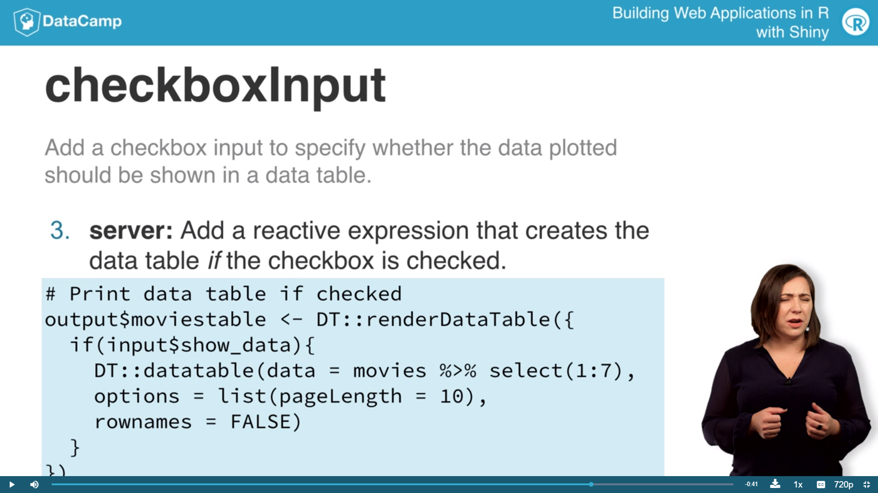

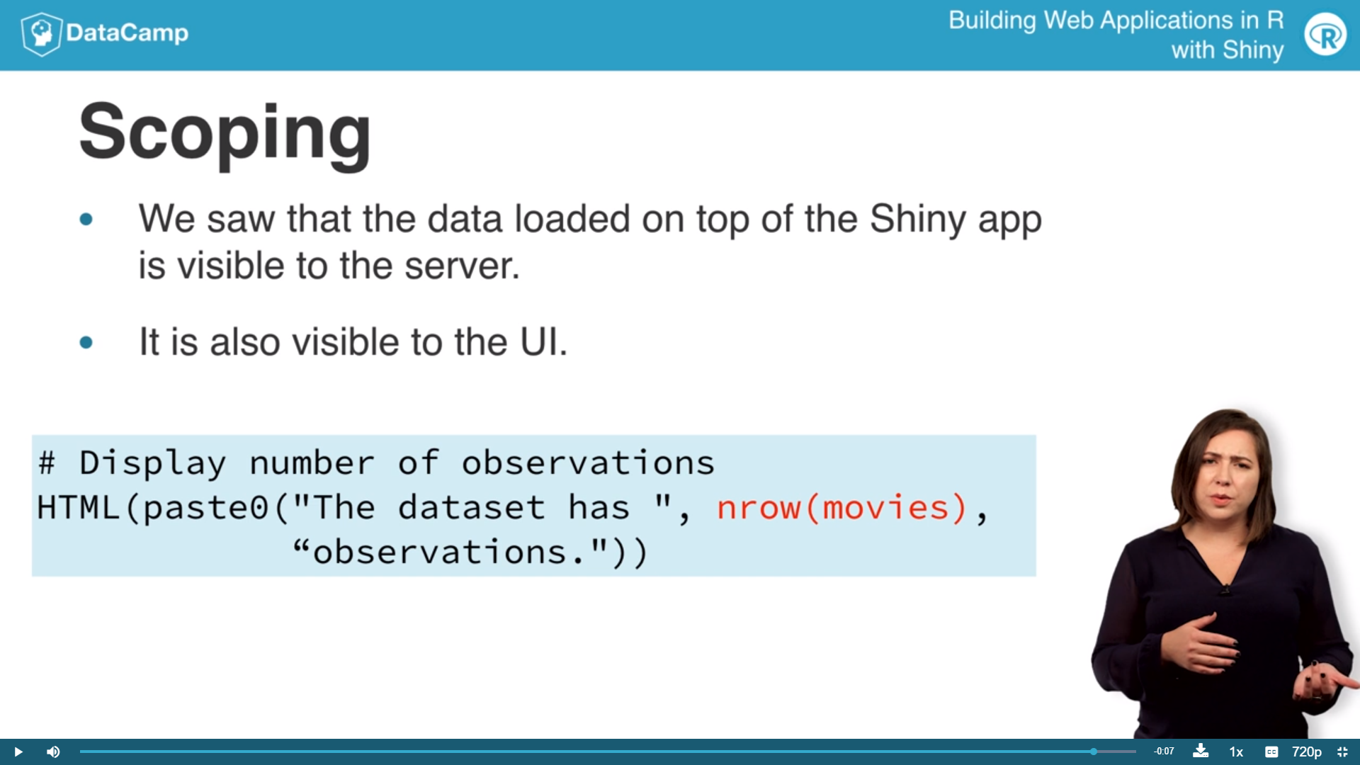

* ui <- fluidPage(

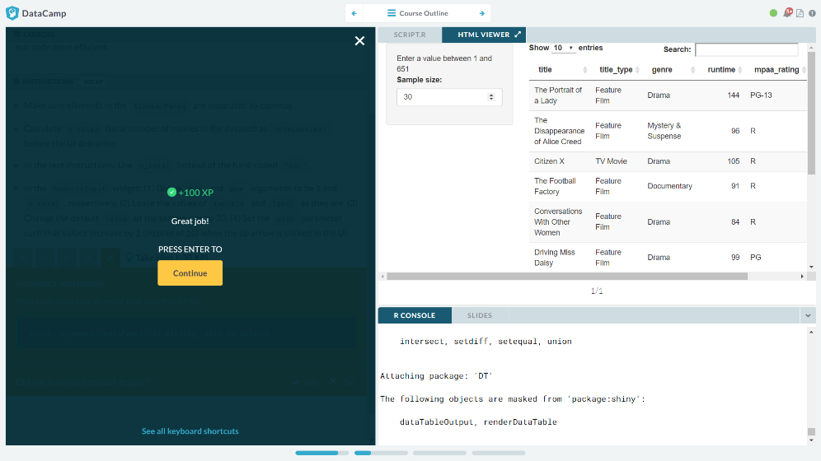sidebarLayout(

# Inputs

sidebarPanel(

# Text instructions

HTML(paste("Enter a value between 1 and 651")),

# Numeric input for sample size

numericInput(min=1,max=n_total,

inputId = "n",

label = "Sample size:",

value = 30, 預設資料顯示筆數

step = 1) 按鈕(上下三角形)按一下增加減少的量

),

# Output: Show data table

mainPanel(

DT::dataTableOutput(outputId = "moviestable")

)

)

server <- function(input, output) {

# Create data table

output$moviestable <- DT::renderDataTable({

movies_sample <- movies %>%

sample_n(input$n) %>%

select(title:studio)

DT::datatable(data = movies_sample,

options = list(pageLength = 10),

rownames = FALSE)

})

}

# Create a Shiny app object

shinyApp(ui = ui, server = server)

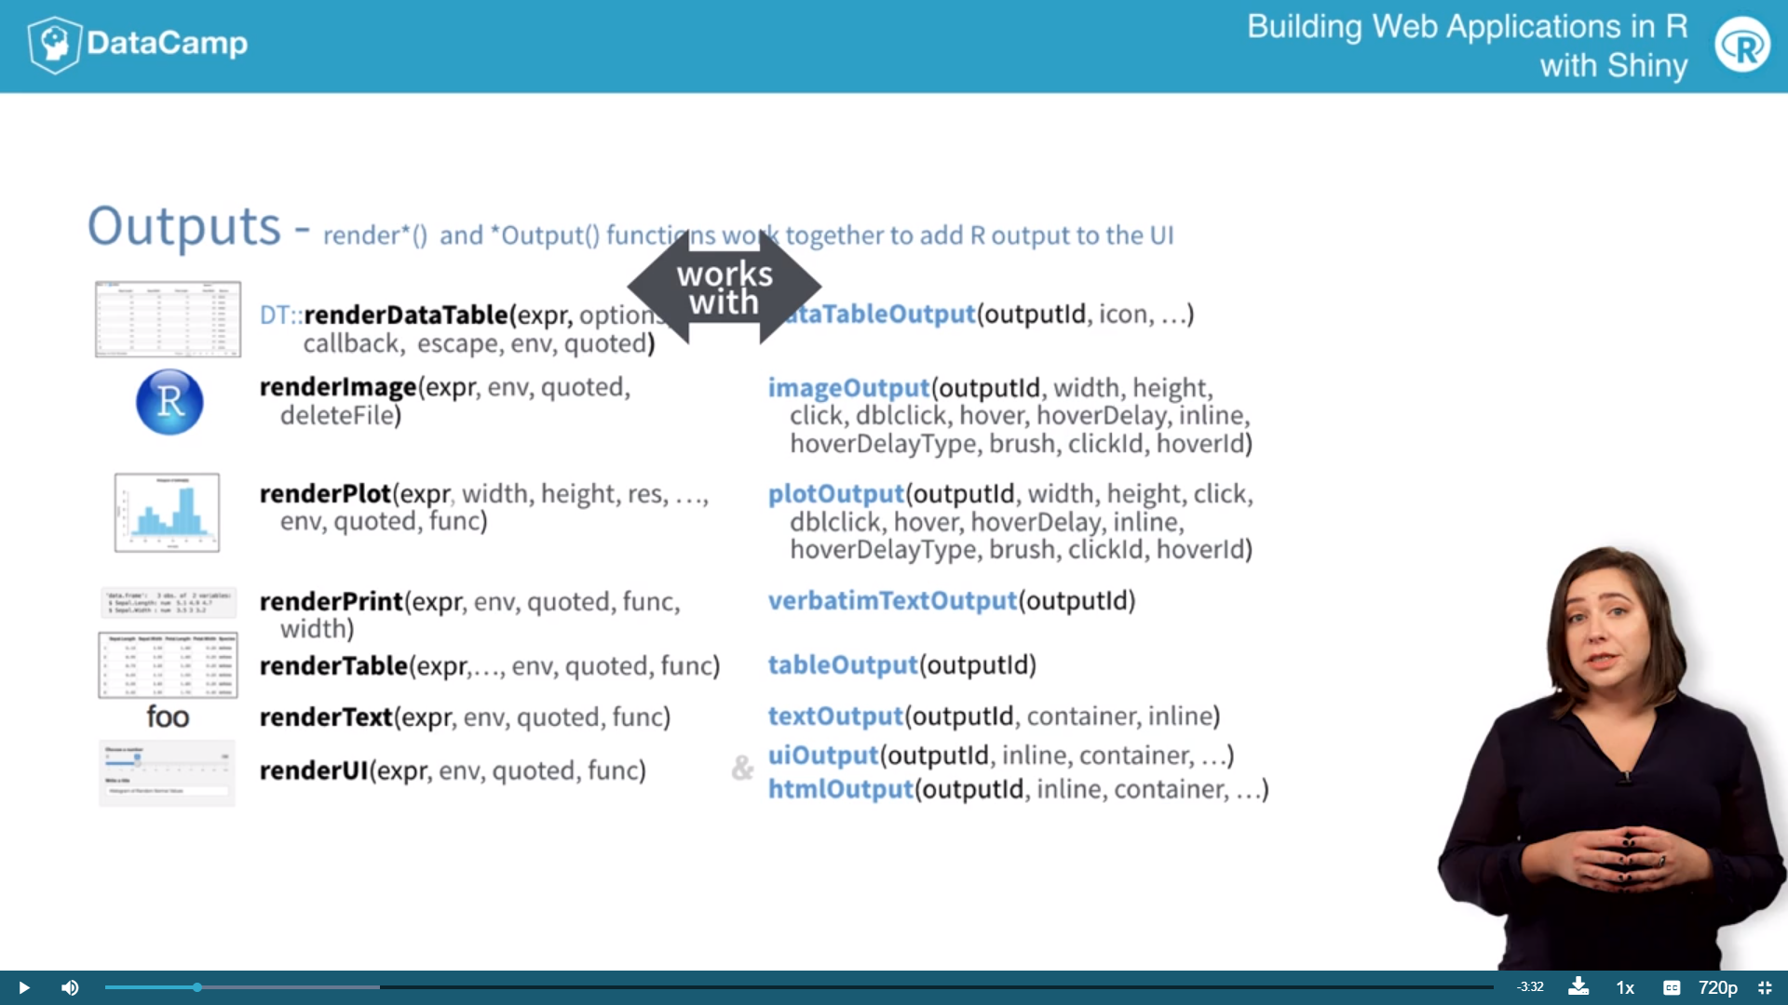

Render 和 相同的Output呼應

* 顯示plot中的資料hover(移動顯示) brush(點擊顯示)

<http://shiny.rstudio.com/articles/selecting-rows-of-data.html>

# 2-Displaying text outputs

* textOutput: 顯示

verbatimTextOutput:

averages of both variables are displayed with textOutput, and the output of a linear regression is displayed with verbatimTextOutput

* downloadHandler() to be used in the server and downloadButton to be used in the UI.